**Programming Fundamentals**

**CA3 Individual Assignment**

**Jan 2023 Semester**

**Name: Jeslyn Ho Ka Yan:**

**ID: 10241485**

**Date of Submission: 13 February 2023**

**Table of Content**

1 What I've learned 3

2 Unresolved 4

3 Unachievable Requirements 5

# What I've learned

1. A good IDE can really help to code much faster. I explorer using eclipse to write the program beside using IntelliJ.
2. This assignment provides an opportunity for me to learn, practice and strength my java programming and debugging skill.

I realised that when the program is not working as expected, it is a good practice to print out the object to examine the output of each step.

1. It also teaches me how to do refactoring of codes to make it more reusable and readable. After writing the basic skeleton of the program, I realised that there are many replicated codes.

Such as search the list for the object. Hence I wrote a common function to search for the list so that it can be easily called by other functions.

1. It is also important to design the overall program flow before starting on the coding.

Having an overall structure of the program enables me to know the interdependency of the functions

E.g. It is more efficient to code the function for show book list first so that I can use this function to check the result of my Add book and Delete book functions.

1. It is also important to consider user experience during the design of the program.

E.g. To delete book, it should also show book list first otherwise user would not know the record id and book id record to remove. Such requirement is not listed in the assignment.

# Unresolved

All requirements are fulfilled. However, there can be some future enhancement for consideration.

**Future Enhancement:**

1. Password should be masked and impose restrictions such as must contain 8 characters with combination of upper and lower case to make the authentication secure.

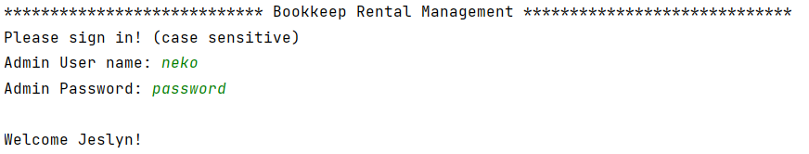

1. Once error exception encounter, system go back to option selection instead of allowing user to re-enter for some functions.

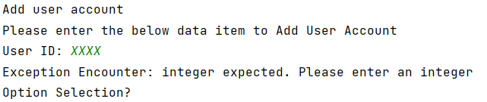

1. When the program start, it will load the Arraylist of adminAccountList, userAccountList, bookList and rentalList from the respective text file. When the program end, it should save by overwrite the text files. Due to insufficient time, I will leave this feature for future enhancement.
2. All the record IDs e.g. user ID, book ID, rental ID should be auto-generated so that user does not need to keep track of the unused numbers.

# Unachievable Requirements

1. To move this application to enterprise level, we need to use a database and make this a web application with a web server.
2. To build a GUI for the application so that it is easier for visualisation and navigation, especially for the function to remove rental records.

The program lists all the rental records for the admin to choose and then enter the rental Id to remove.

The list will be very long for actual implementation. Admin would need to scroll for a long list to search for the rental ID to remove.

It should allow user to choose by clicking on checkboxes to select user account to remove.

1. In real life, book names can contain non ASCII characters such as Chinese book names, the program should be able to handle other non ASCII characters book names.
2. Since the output is in form of command line, display of output in an organised format is challenging. I use tab to print the different elements in columns. However if the name or description is too long or too short, the tab will not be aligned and the result will not be shown in a neat column. It will be good if this can display like a table in html.

